A U D I T F L O W
User Manual
A practical, role-by-role guide to using AuditFlow

Developed by RvTech Solutions Pvt. Ltd.
Prepared for audit firm staff using AuditFlow
Covers Auditor, Company admin, Employee, and Platform admin
August 14, 2026

© 2026 RvTech Solutions Pvt. Ltd. — All rights reserved.

Table of Contents
This list updates automatically when the document is opened in Microsoft Word. If page numbers don't appear, right-click anywhere in the list and choose “Update Field.”

1. What is AuditFlow
AuditFlow is where your audit firm tracks findings raised against your clients — from the moment an issue is discovered, through the person fixing it, to your final sign-off. Everything about a finding lives in one place: who raised it, who it's assigned to, its priority, its due date, the conversation around it, and every piece of evidence attached to it.
The structure behind AuditFlow mirrors how an audit firm actually works: your firm (the “tenant”) audits several client companies, each of which may have its own divisions or regions (sub-companies), and each finding (a “task”) belongs to one of those companies and is assigned to one person.

Who uses AuditFlow
Role | In plain terms
Auditor | Your firm's own staff. Full access — creates clients, invites people, raises findings, assigns them, and signs off (closes) or sends work back (reopens).
Company admin | A contact at the client company. Can see all findings raised against their company and manage their own company's user list, but can't create or edit findings — that stays with your firm.
Employee | Someone (at your firm or the client) who does the actual work on a finding. Sees only the findings assigned to them, updates status, and adds comments/evidence.
Platform admin | AuditFlow's own operations team. Sets up new audit-firm accounts and watches overall platform health — never sees any firm's actual findings.
Note: Which of these sections apply to you depends on your role — the sidebar you see when you sign in only shows the pages you have access to, so you'll never be looking at something you can't use.

2. Signing in
1. Open the AuditFlow sign-in page.
2. Enter your work email and password.
3. Optionally tick “Keep me signed in” if this is your own device — otherwise your session ends when you close the tab.
4. Click Sign in.
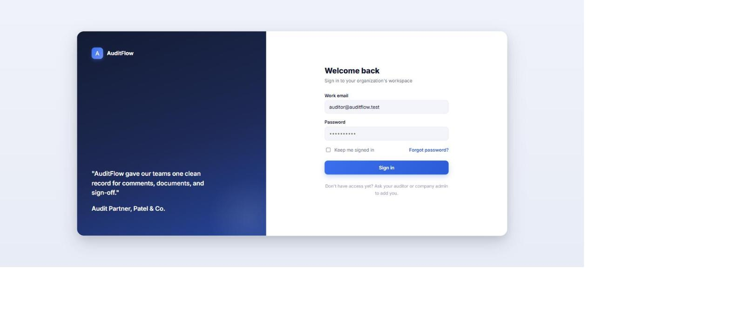
Figure 1 — the sign-in screen

Forgotten your password?
Click “Forgot password?” on the sign-in screen and follow the emailed link to set a new one.

Don't have an account yet?
You can't sign yourself up — an Auditor or your Company admin has to invite you first. You'll receive an email invitation with a link to set your own password (see §8, “Managing users”, for what that invite looks like from the inviting side).

3. Your dashboard
The dashboard is the first thing you see after signing in. What it shows depends on your role — an Employee sees only their own work; an Auditor or Company admin can additionally switch to a broader, portfolio-wide “Executive” view.

3.1 Standard dashboard (everyone)
Four numbers at the top — Overdue, Open, In progress, and Closed this week — each of which you can click to jump straight to that filtered list of tasks. Below that, a table of recently created tasks and a status breakdown chart.
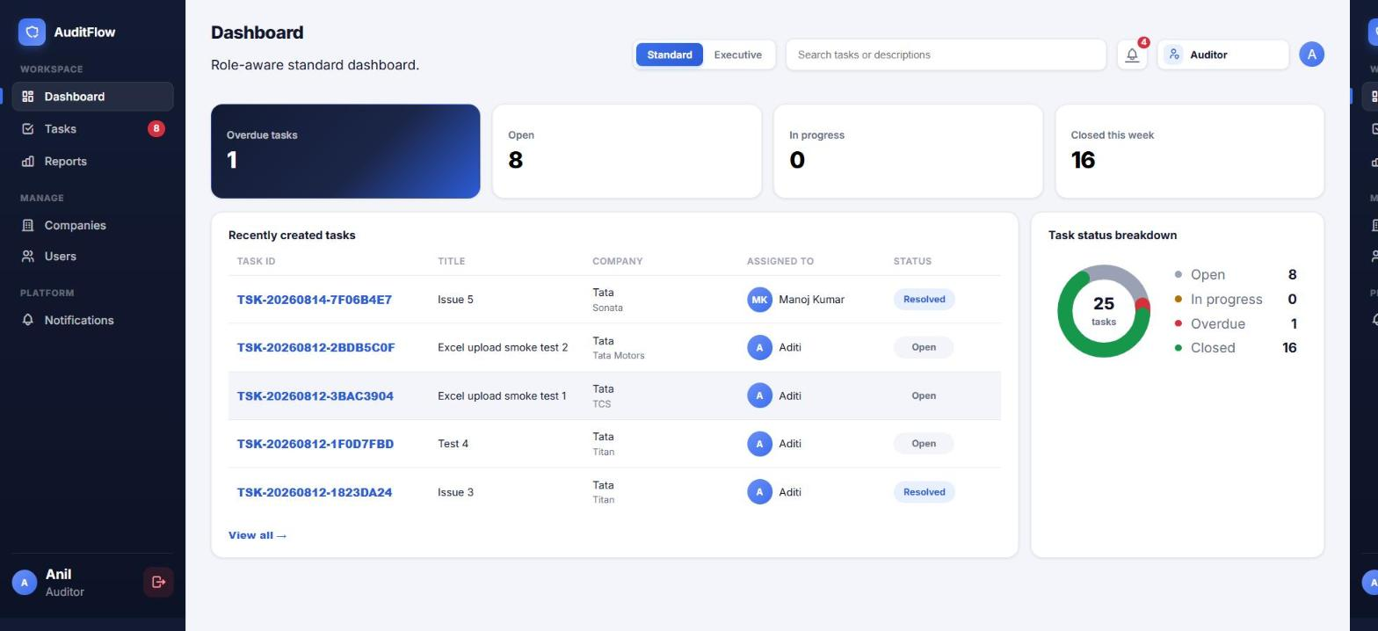
Figure 2 — the Standard dashboard
For an Employee, this dashboard only ever reflects tasks assigned to them — the numbers, the table, and the chart are all scoped to their own work.
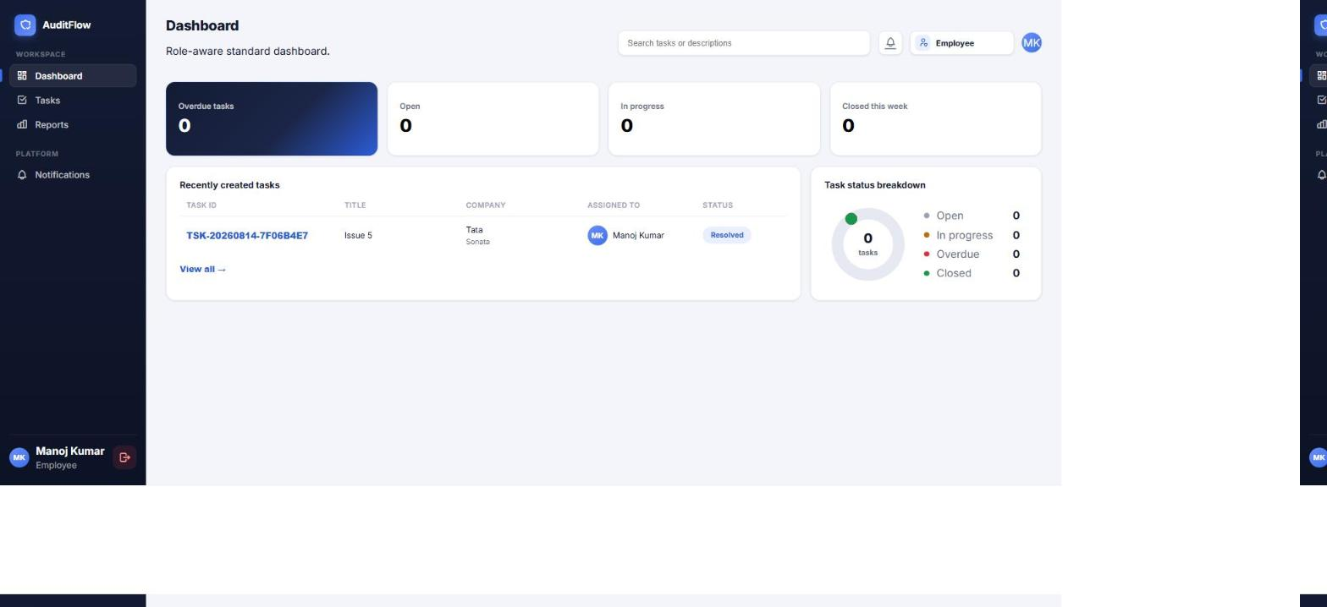
Figure 3 — the Standard dashboard as seen by an Employee (their own tasks only, no client/company management in the sidebar)

3.2 Executive dashboard (Auditor and Company admin only)
Switch to it with the Standard / Executive toggle at the top of the Dashboard page. This view is built for a portfolio-level check-in rather than day-to-day task work: filter by client, sub-company, status, or date range, and every chart on the page recalculates.
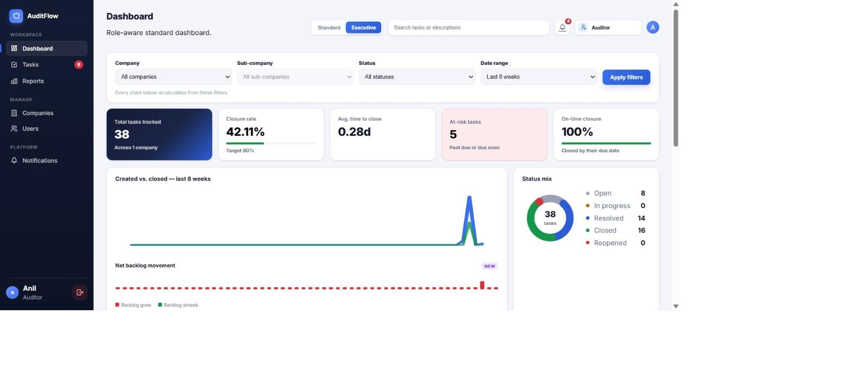
Figure 4 — Executive dashboard: filters, the five key metrics, and the trend/status charts
- Total tasks tracked, Closure rate, Avg. time to close, At-risk tasks, and On-time closure — the first, second, and fourth of these are clickable and take you straight to the matching filtered task list.
- Created vs. closed — a trend line across the selected date range, with a Net backlog movement strip underneath it showing whether the backlog grew (red) or shrank (green) each period.
- Status mix — a donut of every task's current status; click any status in the legend to filter by it.
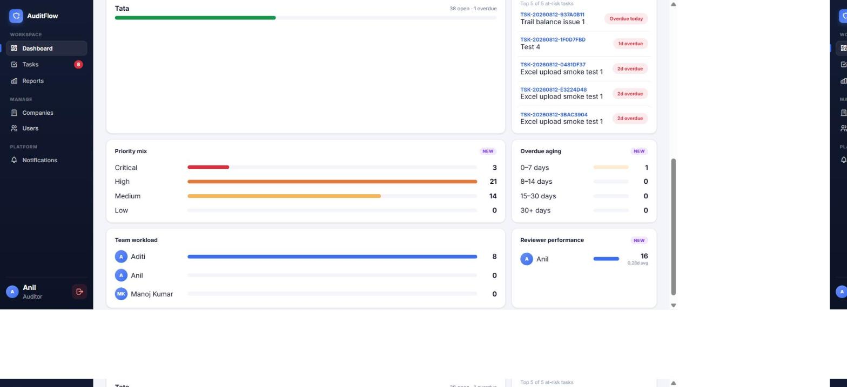
Figure 5 — Executive dashboard: risk, priority, aging, and team widgets
- Company health — closure rate per client, so you can see at a glance which client's findings are lagging.
- Highest-risk tasks — the most urgent overdue/at-risk findings across your whole portfolio; click a row to open that task directly.
- Priority mix and Overdue aging — how much of the backlog is Critical/High priority, and how long overdue tasks have been sitting.
- Team workload and Reviewer performance — who's carrying the most open work, and who's closing the most findings and how fast.
Note: Company admin sees the Executive dashboard locked to their own company — the Company filter can't be changed.

4. Working with tasks (findings)
A “task” is a single audit finding — from a missing document to a control failure — tracked from the moment it's raised through to sign-off.

4.1 Viewing tasks
The Tasks page shows a filterable, paginated grid. “Current week” shows what's newest; “Full list” (via the toggle button) shows everything, including historical audit periods.
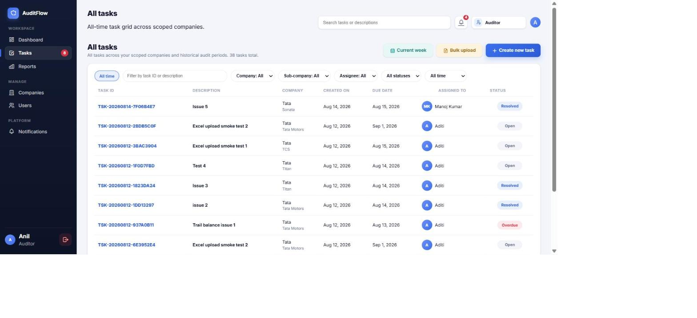
Figure 6 — the task grid (Auditor view — full access to every client)
Role | What they see in this grid
Auditor | Every task across every client company they're scoped to. Can create new tasks, bulk-upload, and use every filter.
Company admin | Every task for their own company, view-only — no “Create” or “Bulk upload” button.
Employee | Only tasks assigned to them, with the Assignee filter locked to “Assigned to you”.
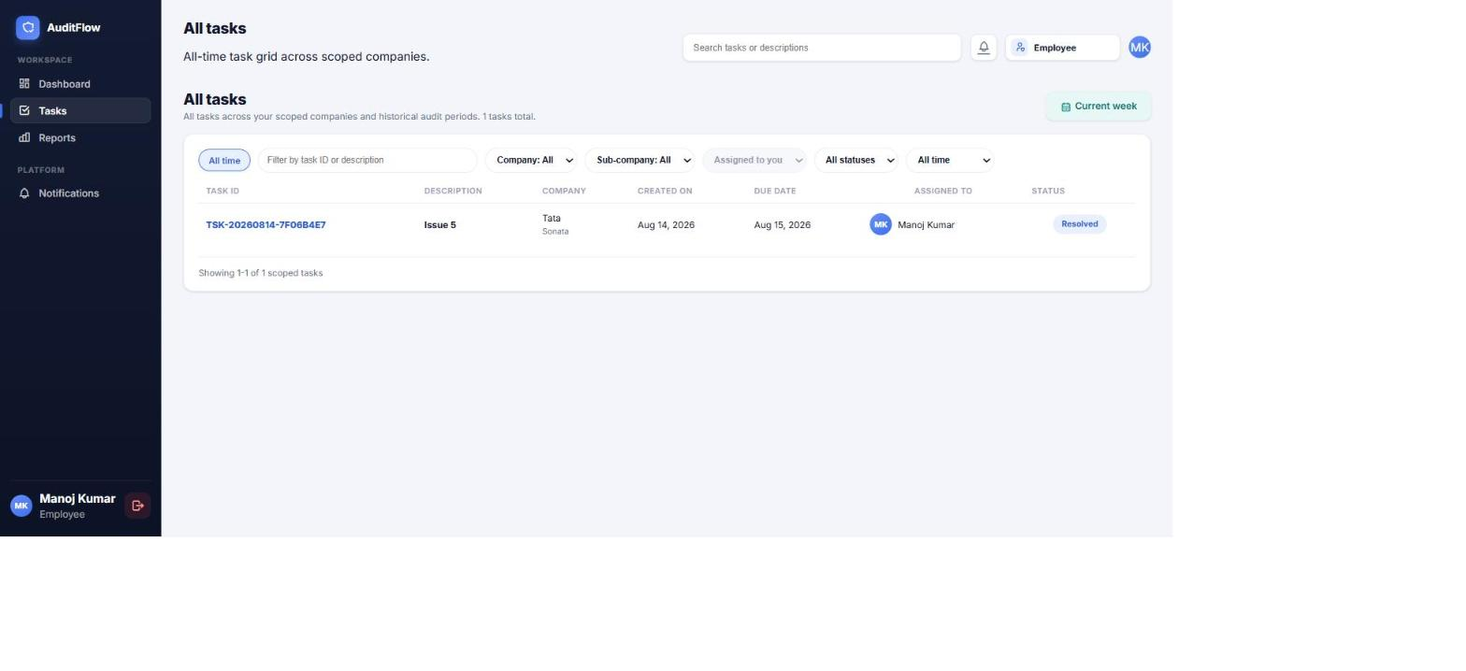
Figure 7 — the task grid as seen by an Employee (scoped to their own assignments only)
The Status filter includes two special views worth knowing about: Overdue (past its due date) and At risk (overdue or due within the next 7 days) — both are useful for triaging what needs attention first.

4.2 Creating a task (Auditor only)
1. From the Tasks page, click Create new task.
2. Give it a clear title and a description of what was found and what was expected instead.
3. Choose the Company and Sub-company it applies to.
4. Assign it to the person who'll fix it, and set a Priority (Low / Medium / High / Critical).
5. Set a Due date.
6. Optionally attach evidence (drag a file in, or paste a screenshot with Ctrl+V) — up to 10MB per file.
7. Save. The assignee is notified immediately.
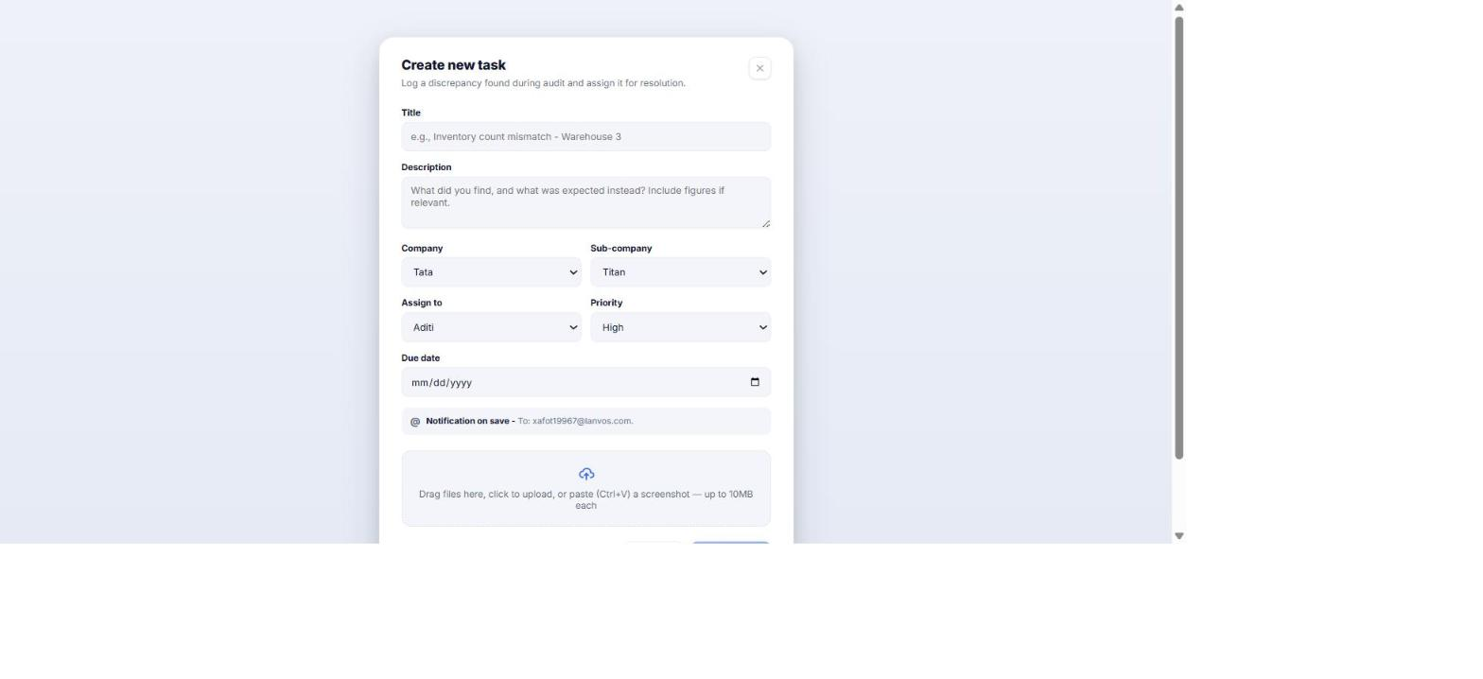
Figure 8 — creating a new task

4.3 Creating many tasks at once (bulk upload, Auditor only)
1. From the Tasks page, click Bulk upload.
2. Download the Excel template — it has the exact columns AuditFlow expects (title, description, company, sub-company, assignee email, priority, due date).
3. Fill it in and upload it back (CSV or Excel accepted).
4. AuditFlow shows you a preview and flags any row with a problem before anything is actually created — fix and re-upload, or proceed with just the valid rows.
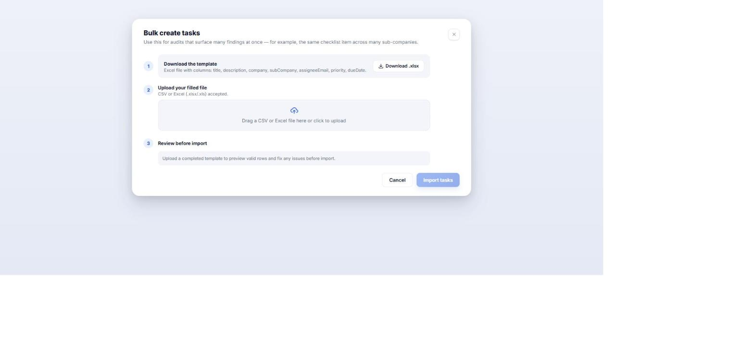
Figure 9 — bulk-creating tasks from a spreadsheet
This is the fastest way to log a batch of findings that surfaced all at once — for example, the same checklist gap found across several sub-companies.

5. Inside a task — the four tabs
Click any task to open it. Every task has four tabs: Overview, Comments, Documents, and Timeline.

5.1 Overview
The task's core fields, plus a Task fields panel on the right showing who created it, when, and who it's assigned to.
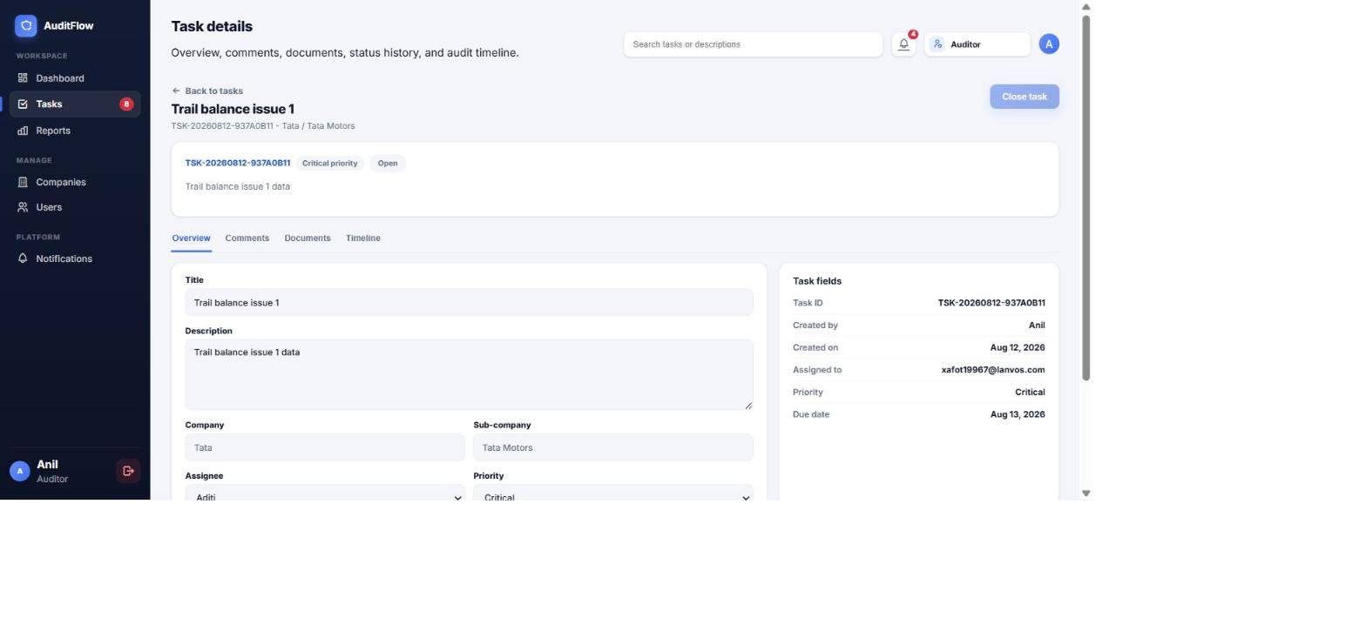
Figure 10 — Overview tab (Auditor — every field is editable)
Role | What they can change here
Auditor | Everything — title, description, priority, due date, assignee, and status.
Company admin | Nothing — view-only, by design.
Employee | Only the Status field. Title, description, priority, due date, and assignee stay read-only.
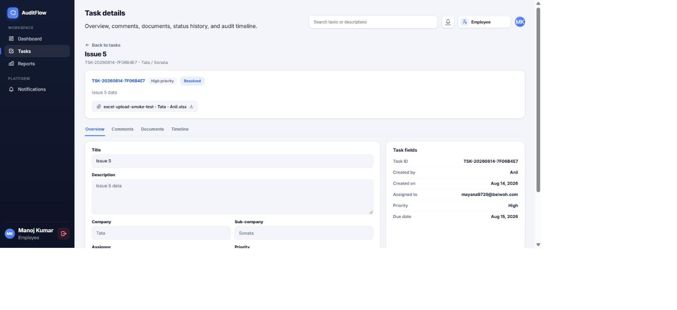
Figure 11 — Overview tab as seen by an Employee, with an evidence file attached at creation
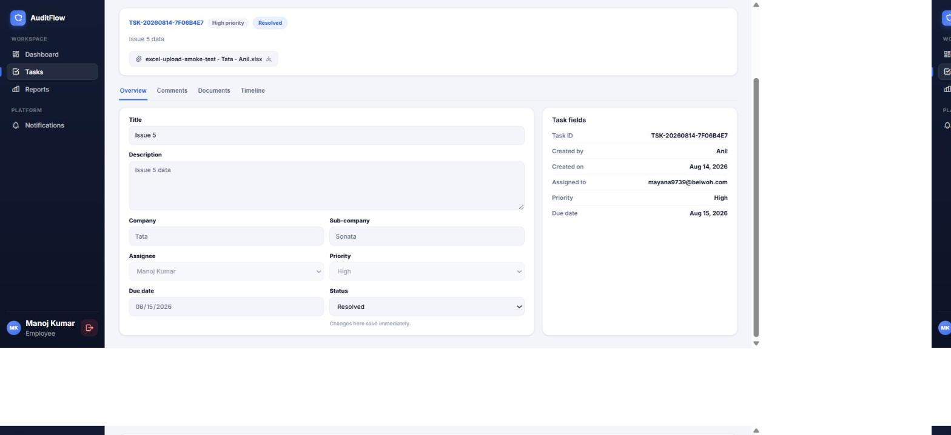
Figure 12 — an Employee's Status dropdown is the one field they can change; it saves immediately

5.2 Comments
A running conversation on the task. Type a note and click Add comment — you can also paste a screenshot directly into the box (Ctrl+V) to attach it inline with your comment.
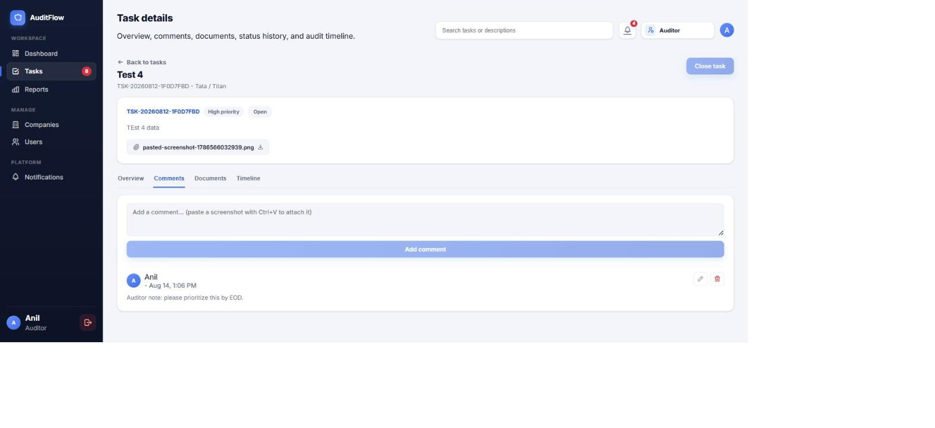
Figure 13 — the Comments tab, with edit/delete icons on a comment
- You can edit or delete your own comments (the pencil/trash icons only appear on comments you wrote).
- An Auditor can additionally edit or delete anyone's comment on a task they have access to — useful for moderating a thread.
- Company admin can read comments but not post one — commenting is limited to Auditor and Employee.

5.3 Documents
Evidence files and supporting schedules attached to the task directly (separate from anything pasted into a specific comment).
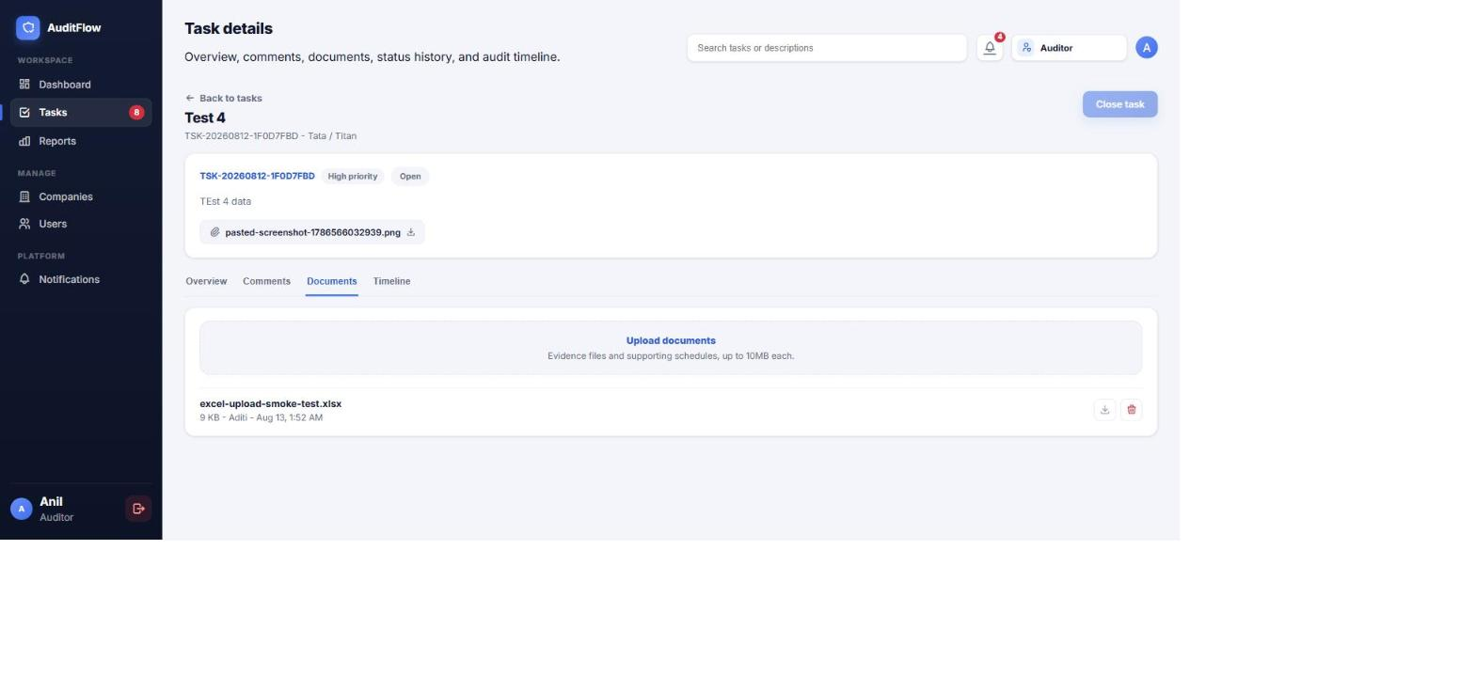
Figure 14 — the Documents tab
- Anyone with access to the task can download a document.
- You can delete a document you uploaded yourself; an Auditor can delete any document on the task.
- Up to 10MB per file.

5.4 Timeline
An audit trail of every status change — Open, In progress, Resolved, Closed — with who made the change, when, and (for a reopen) why.
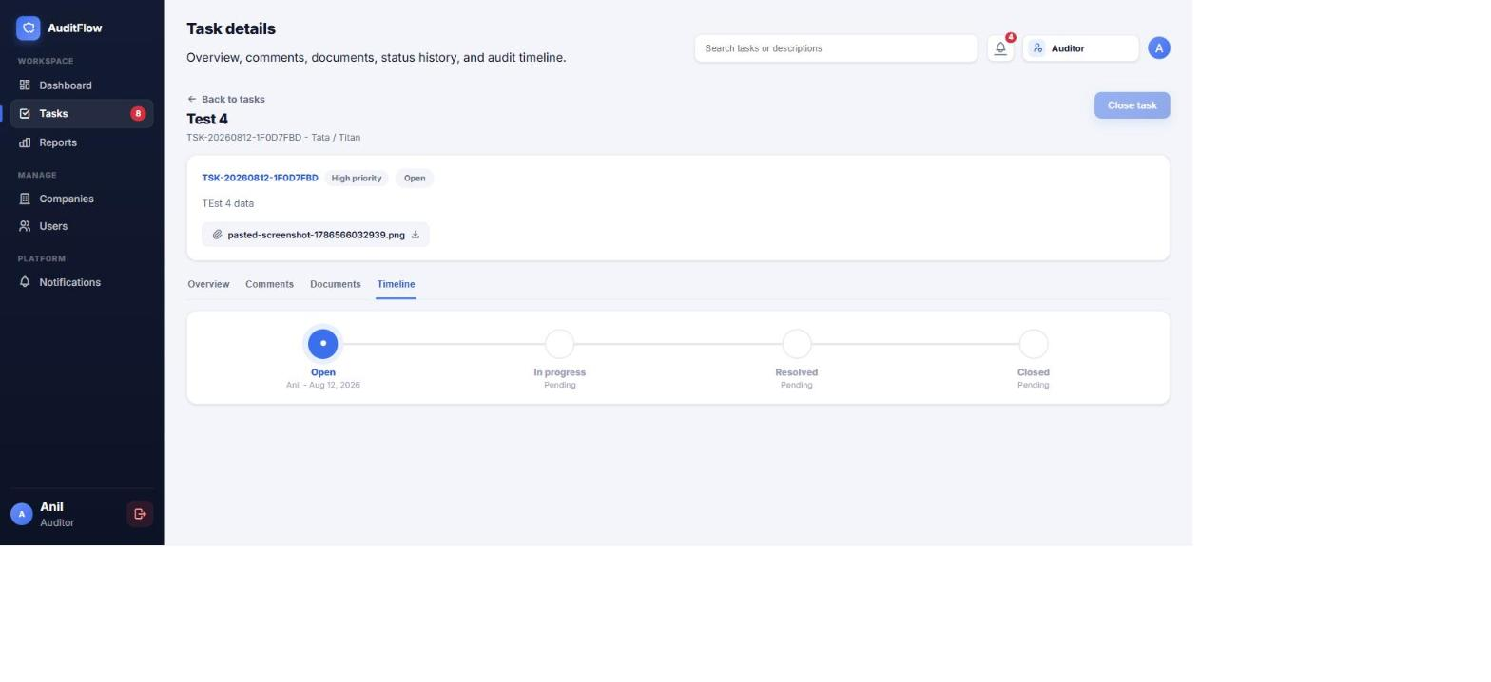
Figure 15 — the Timeline tab

5.5 The status lifecycle
A task moves through Open → In progress → Resolved → Closed. “Resolved” means the assignee believes the work is done and it's now awaiting the Auditor's sign-off — it is not the same as finished. Only an Auditor can Close a task (and only once it's Resolved), and only an Auditor can Reopen a closed task — which always requires typing a reason, since it's effectively overturning a prior sign-off.
An Employee can move a task Open → In progress, In progress → Resolved or back to Open, and Resolved back to In progress if more work is needed — but can never close or reopen a task themselves.

6. Reports
The Reports page lets you filter your scoped tasks and export them as an Excel workbook or a formatted PDF. Available to every role — an Auditor or Company admin sees everything in scope; an Employee's export is limited to their own assigned tasks (the same scoping as everywhere else).
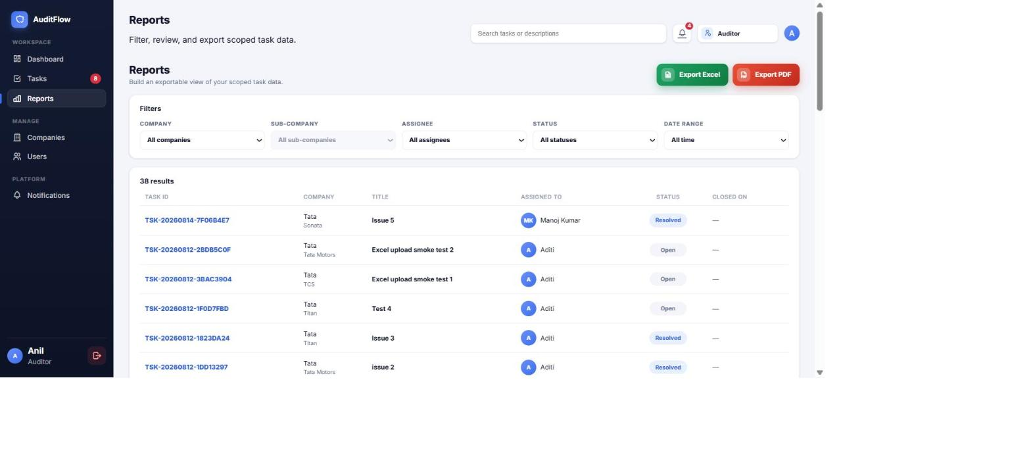
Figure 16 — the Reports page (Auditor view)
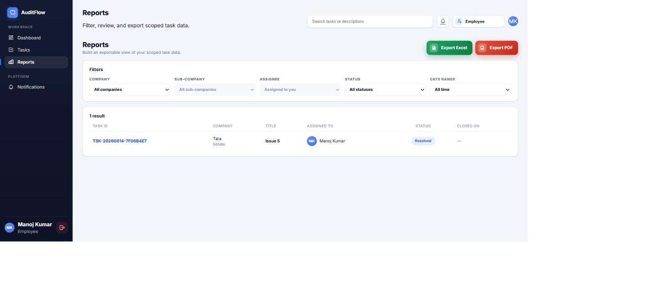
Figure 17 — the Reports page as seen by an Employee, scoped to their own work
1. Set your filters (company, sub-company, assignee, status, date range).
2. Click Export Excel or Export PDF.
3. For a small result set the file downloads immediately.
4. For a very large export, AuditFlow queues it as a background job instead — you'll get a notification when it's ready to download, rather than waiting on the page.

7. Managing client companies (Auditor only)
Every task belongs to a Company (a client of your firm), optionally narrowed to a Sub-company (a division or region within that client). Set these up once, before raising findings against them.
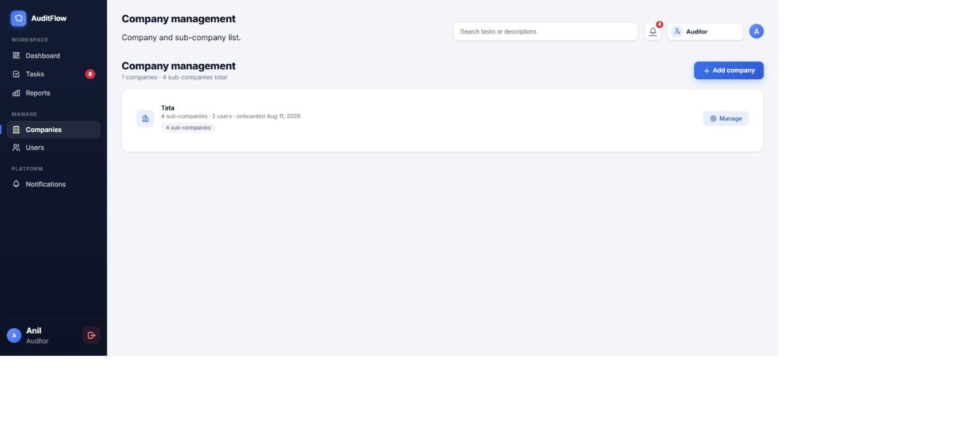
Figure 18 — Company management
Click Add company to onboard a new client, or Manage on an existing one to add/edit its sub-companies.

8. Managing users
Auditors can invite anyone (Employee, Company admin, or another Auditor) across any of their client companies. Company admins can invite people into their own company only, and only as Employee or Company admin — inviting a new Auditor is reserved for existing Auditors.
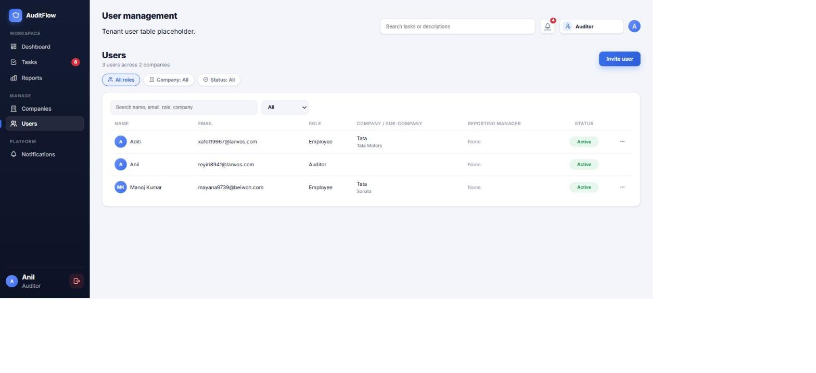
Figure 19 — the user directory (Auditor view)
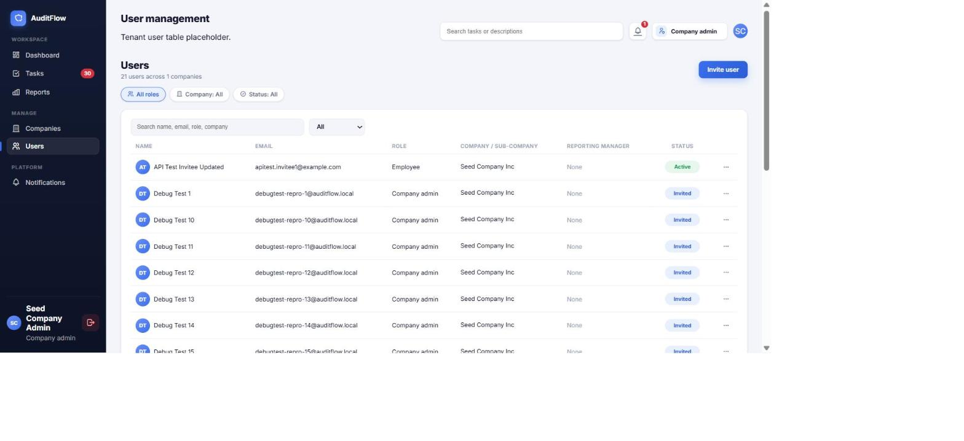
Figure 20 — the user directory as seen by a Company admin (their own company only)

Inviting someone
1. Click Invite user.
2. Enter their full name and email.
3. Pick their Role.
4. Choose the Company (and Sub-company access, if applicable).
5. Optionally set a Reporting manager — task notification emails CC them.
6. Click Send invite. The person receives an email invite to set their own password and join.
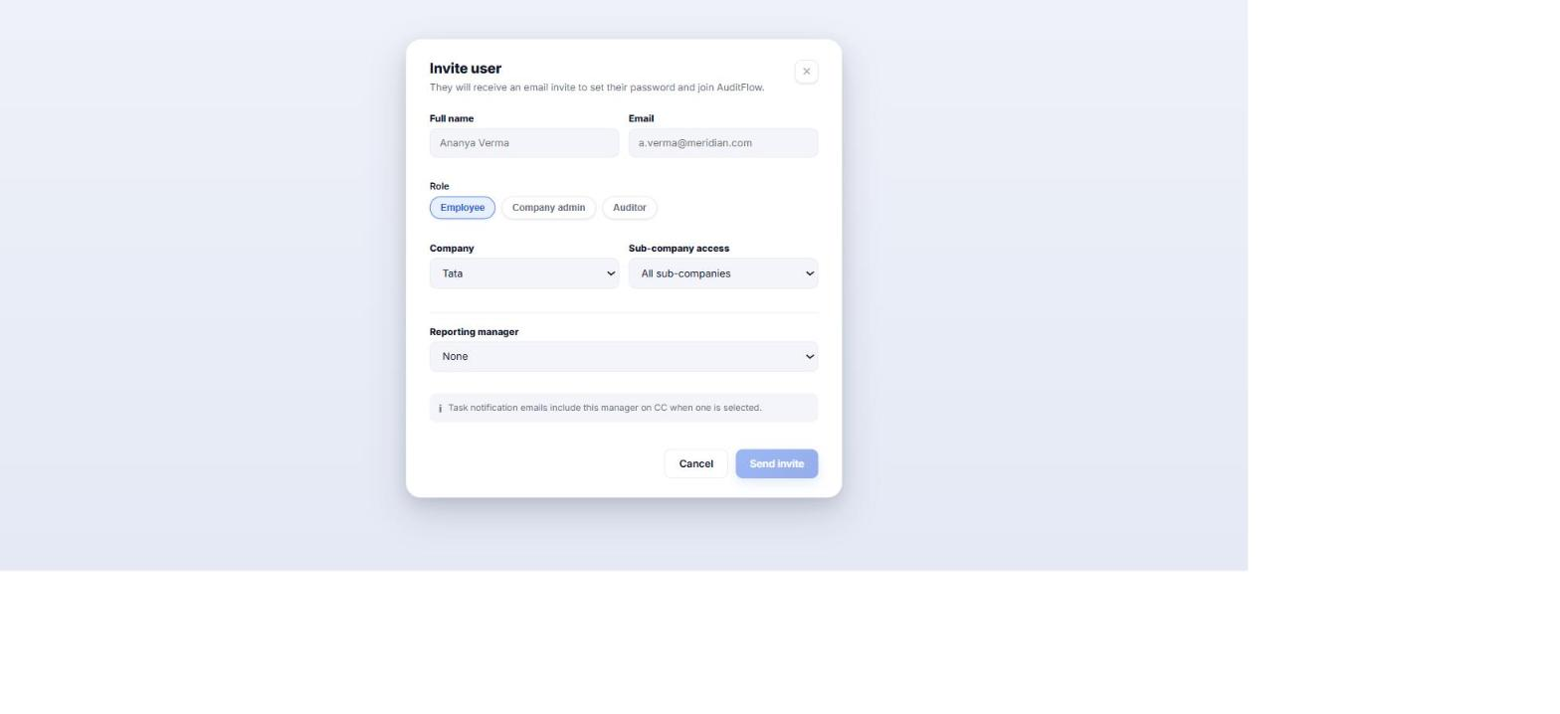
Figure 21 — inviting a new user
From the user list you can also deactivate or reactivate someone via the ••• menu on their row — a deactivated user can no longer sign in, but their history (comments, tasks they created/closed) is preserved.

9. Notifications
AuditFlow notifies you when a task is assigned to you, its status changes, someone comments on it, or a report you requested finishes generating. The bell icon in the top bar shows your unread count; the Notifications page lists everything.
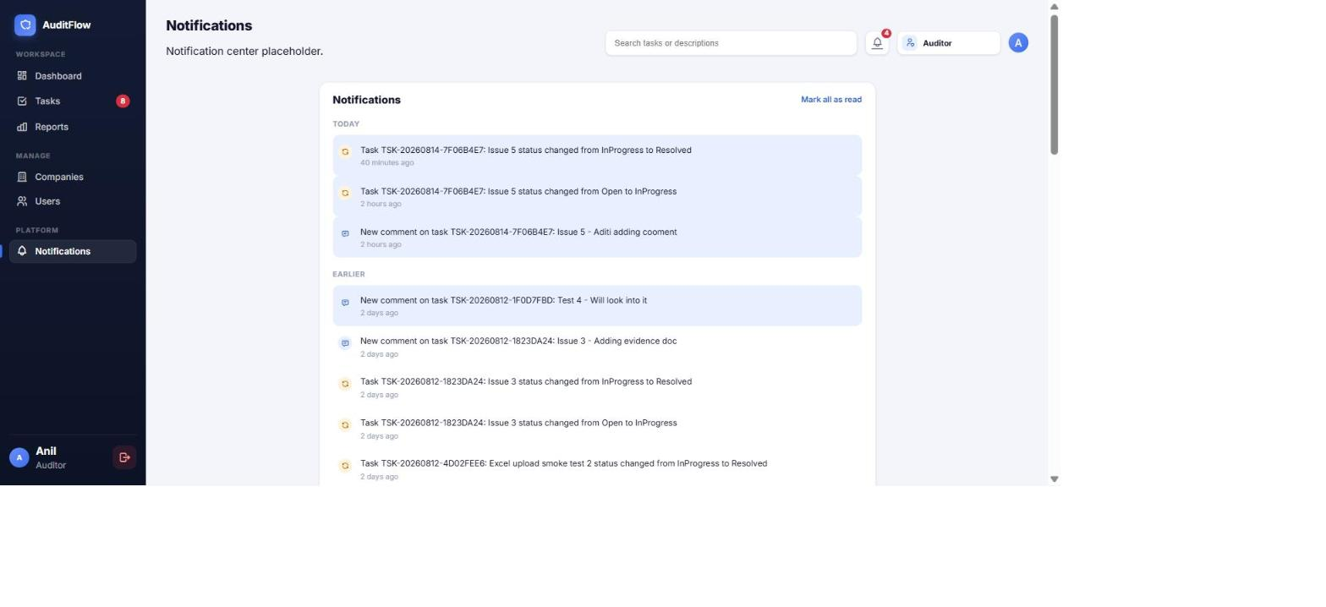
Figure 22 — the Notifications page
Click Mark all as read to clear the badge, or click an individual notification to jump straight to what it's about.

10. Your profile
Reachable from your name/avatar at the bottom of the sidebar. This is where you control how AuditFlow looks and how it reaches you.
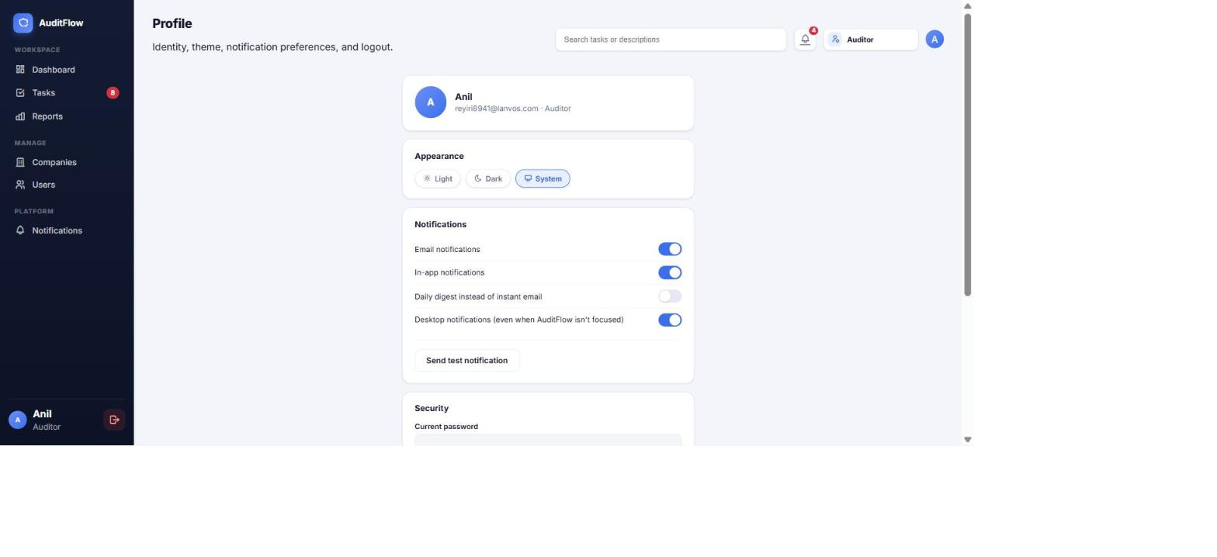
Figure 23 — the Profile page
- Appearance — Light, Dark, or match your System setting.
- Notifications — toggle email, in-app, and desktop notifications independently, or switch to a once-daily digest email instead of instant emails.
- Security — change your password, and sign out.

11. For AuditFlow's own team (Platform admin)
Note: This section only applies to AuditFlow's internal operations staff. A Platform admin manages the audit-firm accounts themselves and never sees any firm's actual clients, tasks, or findings — that separation is enforced by the system, not just a UI convention.

Auditor accounts
The list of every audit firm on the platform, with a quick view of their company/user/task counts and subscription plan.
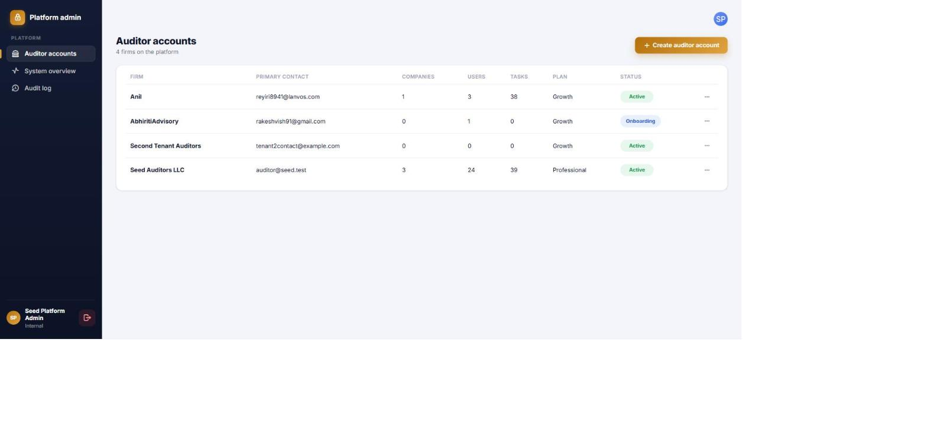
Figure 24 — Auditor accounts (tenant list)

Creating a new audit firm account
1. Click Create auditor account.
2. Enter the firm's name and choose a plan.
3. Enter the primary contact's name and email — they become that firm's first Auditor login and receive an email invite.
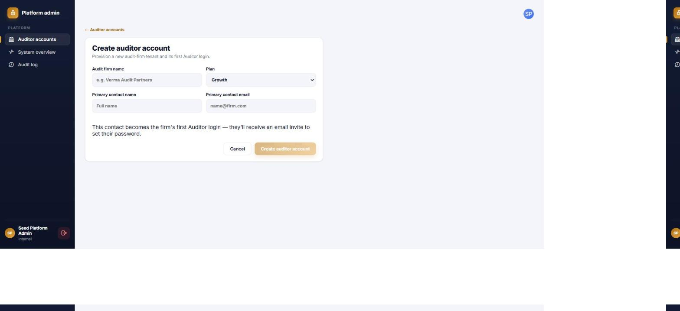
Figure 25 — provisioning a new audit firm

System overview
Platform-wide health at a glance — active firms, total users, companies, and tasks across every tenant, plus basic environment info.
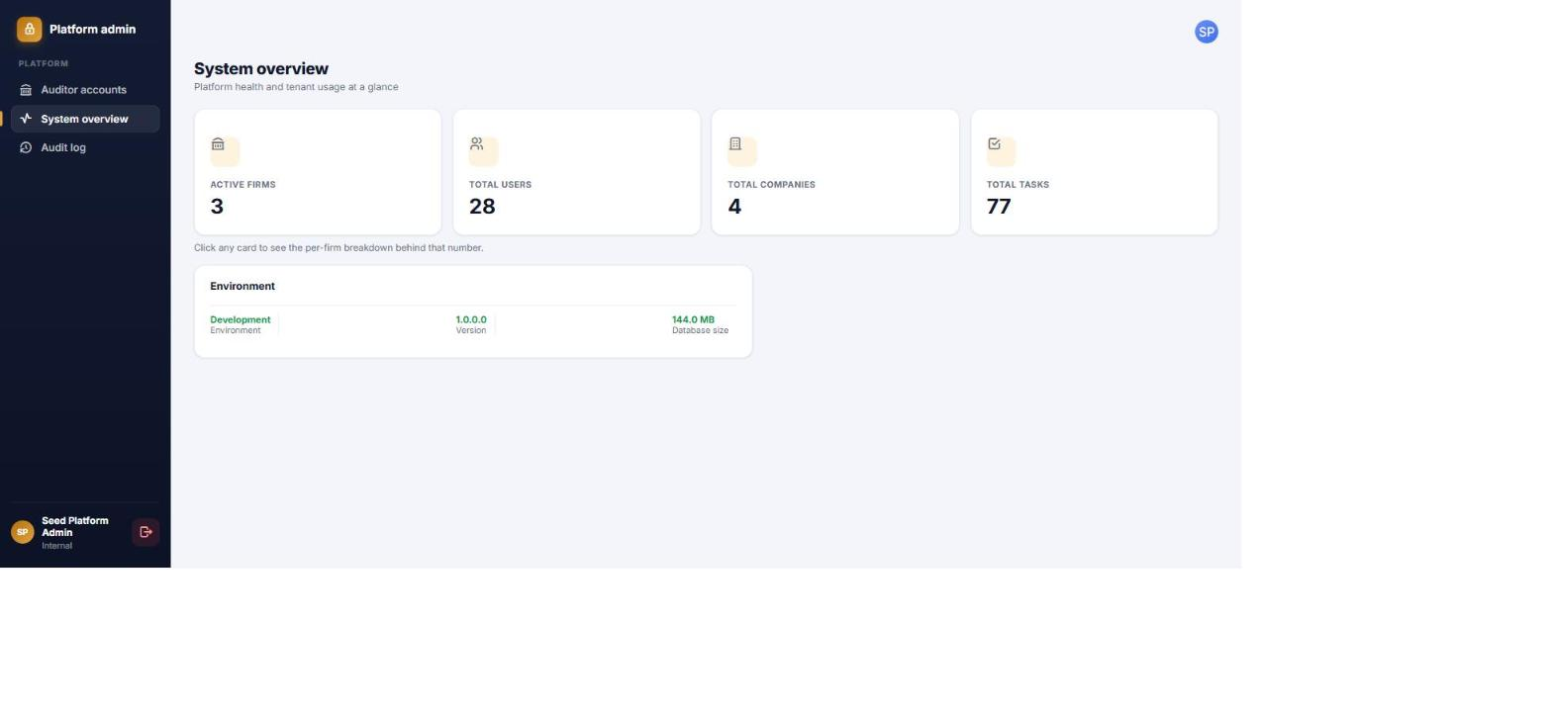
Figure 26 — System overview

Audit log
A record of administrative activity across every firm — logins, account changes, and similar events — filterable by entity, action, and date.
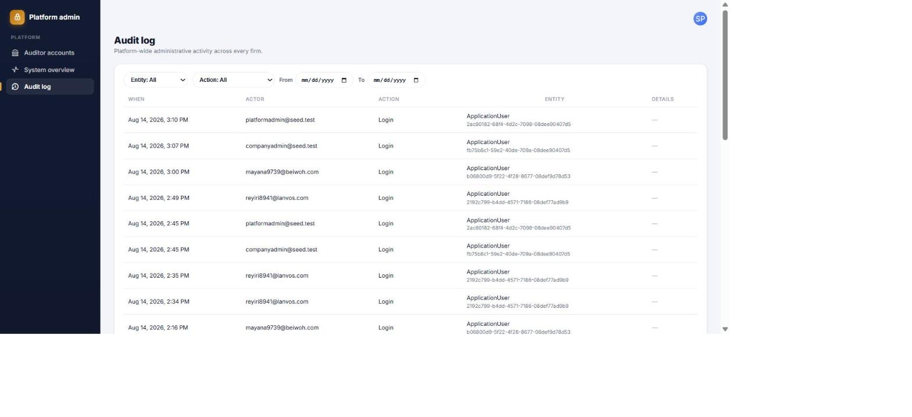
Figure 27 — Audit log

12. Frequently asked questions
Question | Answer
I can't see a task I know exists. | You only see tasks within your scope — your own assignments (Employee), your company (Company admin), or the companies you're mapped to (Auditor). Ask your Auditor to check the task's company/assignee.
I got signed out unexpectedly. | Your session expired after a period of inactivity. Just sign in again — nothing is lost.
I don't see an Executive dashboard toggle. | Only Auditors and Company admins have the Executive view; Employees see the Standard dashboard only.
I can't edit a task's title/priority/due date. | Only an Auditor can edit those fields. Company admin is view-only on tasks, and an Employee can only change a task's Status.
Why can't I close or reopen a task? | Closing and reopening are Auditor-only actions — reopening always requires typing a reason.
My export button is greyed out or I got an error about the export being too large. | Very large exports are queued as a background report instead of downloading immediately — watch your notifications for “Report ready.”
Who do I contact for access? | Your firm's Auditor (or your Company admin, if you're on the client side) — they can invite you or adjust your access.

